- In the previous week, we learned about different commands to create the file with different file extensions.
  - In the desktop create the batch file name it pingdomain.bat
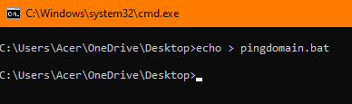

  - In that particular batch file, write the script to ping the server by taking a user input.
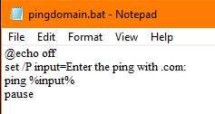
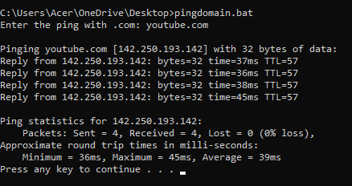

- Create a batch file Nepal.bat, write the batch script to create a txt file having text: I am learning batch file in week-10. 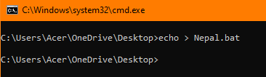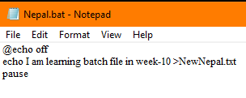
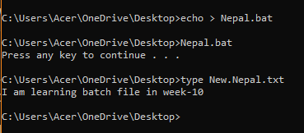

- Create the batch file to show the system information in the text file info.
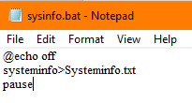
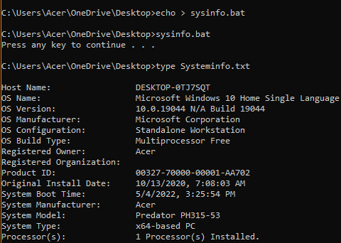
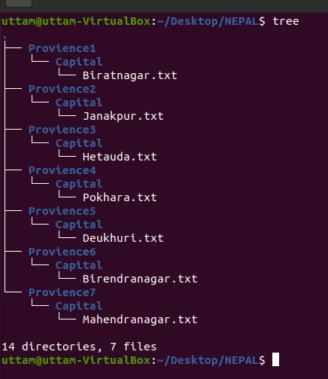
- Create the batch file which contains the command to create the below diagram.

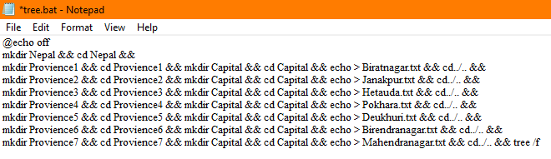
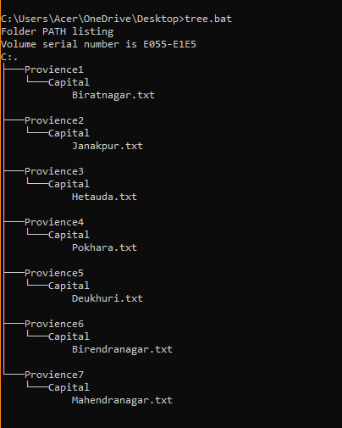

- Create a batch script that automatically backs up your documents folder.
Note: create a backup folder in the desktop and copy the contents of documents into that folder and use windows task scheduler.

